Stage 4 - Circus
COURSE DESIGNER: Rocky Perillo

SCORING: Comstock 26 rounds.
TARGETS: 12 cardboard targets, 2 steel targets
SCORED HITS: 2 Best hits per carboard will be scored. Steel must fall to score.

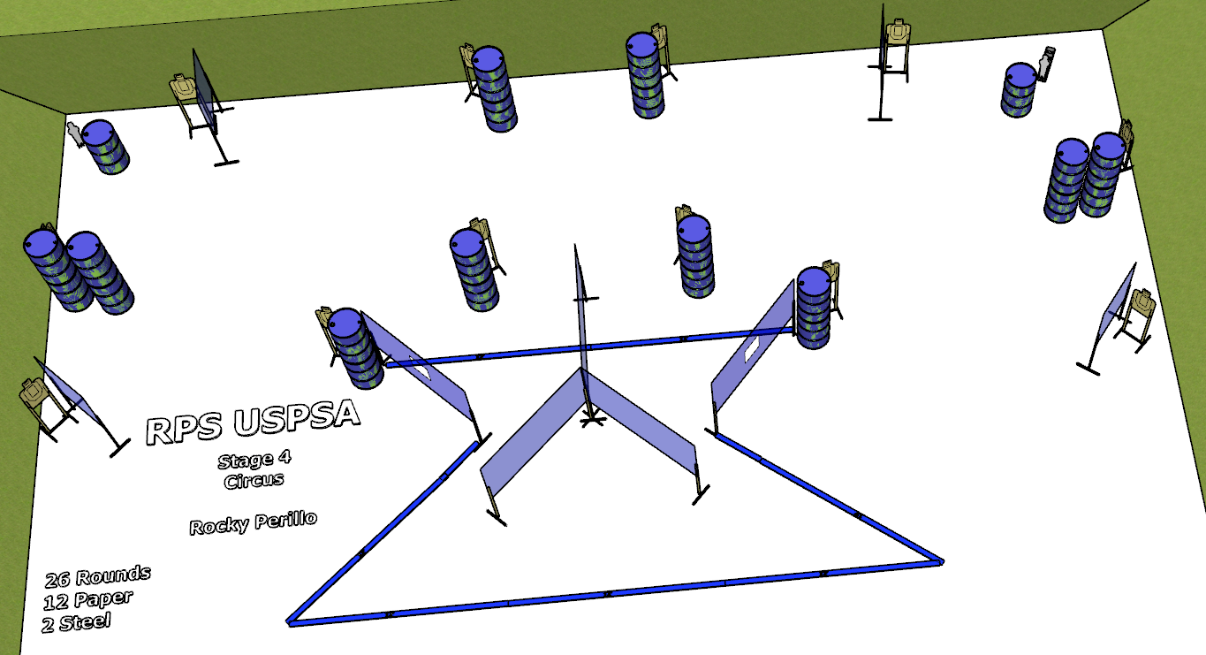

Written Stage Briefing:

Stage 4 - Circus - is a 26 round, 130 point, Comstock course. There are 12 cardboard targets and 2 steel targets. The best 2 hits per cardboard target will be scored. The steel must fall to score.
Start position Anywhere
Handgun: Loaded and holstered, wrists below belt.
PCC: Loaded, stock touching belt.

On the audible start signal, engage targets from within the shooting area.

USPSA / NROI Range Commands:
- Make Ready
- Are you ready?
- Standby
- If finished, unload and show clear.
- If clear, hammer down and holster
- Range is clear

Setup Notes:
15 Single Wall Stands
1 Triple Wall Stand
3 Full Walls
2 Port Walls
4 Half Walls
12 Target stands / 24 target sticks
22+ barrels

